Software Requirements Specification

for

<Product Trading Online System>

Version 1.3 approved

Prepared by HieuNV

FPT University

22/3/2020

Table of Contents

Table of Contents ii

Revision History ii

1. Introduction 2

1.1 Purpose 2

1.2 Document Conventions 2

1.3 Project Scope 2

1.4 References 2

2. Overall Description 2

2.1 Product Perspective 2

2.2 User Classes and Characteristics 2

2.3 Operating Environment 2

2.4 Design and Implementation Constraints 2

2.5 Assumptions and Dependencies 2

3. System Features 2

3.1 System Feature Manage User 2

3.2 System Feature Manage Product 2

3.3 System Feature Order Product 2

3.4 System Feature Login/Logout 2

3.5 System Feature Choose Language 2

3.6 System Feature Register 2

4. Data Requirements 2

4.1 Logical Data Model 2

4.2 Data Dictionary 2

4.3 Reports 2

4.4 Data Acquisition, Integrity, Retention, and Disposal 2

5. External Interface Requirements 2

5.1 User Interfaces 2

5.2 Software Interfaces 2

5.3 Hardware Interfaces 2

5.4 Communications Interfaces 2

6. Quality Attributes 2

6.1 Usability 2

6.2 Performance 2

6.3 Security 2

6.4 Safety 2

6.5 [Others as relevant] 2

7. Internationalization and Localization Requirements 2

8. Other Requirements 2

Appendix A: Glossary 2

Appendix B: Analysis Models 2

Revision History

|  |  |  |  |
| --- | --- | --- | --- |
| **Name** | **Date** | **Reason For Changes** | **Version** |
| Update table content | 12/3/2020 |  | 1.0 |
| Update system feature | 19/3/2020 |  | 1.1 |
| Remove child use-case image | 20/3/2020 | Child use-case image it not in the requirement | 1.2 |
| Update context and use-case diagram | 20/3/2020 |  | 1.2 |
| Update logic data model | 22/3/2020 | Add more entity | 1.3 |
| Add more content in section 7 and 8 | 22/3/2020 |  | 1.3 |

# Introduction

## Purpose

Today, each of us has a lot of needs for material life, food houses. Besides, we have to work and take a lot of time. So it is not easy to have time to shop, so we have created this product with the purpose of making it easier for users to order products remotely. This chapter provides an overview of the project including background information and documents

review the existing system and make a proposal for improvement ideas.

## Document Conventions

A web-based application for a transactional product system, users can post information about products and add products to the cart.

and buy them and even help them get their goods at home easily and quickly.

## Project Scope

This app is for all items including household appliances, food, cosmetics, books and many other items. This app will make buying and selling goods easier, with features like ours designed like search product by name of them, login, logout, ...

## References

- Software requirement specification form

- SRS of Tiki Ordering System

- Software engineering – Ninth Edition

# Overall Description

## Product Perspective

This software product is eventually intended for everybody who want to shopping online, since there are a lot of thing people want to look for product that offer their need, some just want to find the product with a good deal and other just need the information about the product. So our team decide to build a website based on that demands.

Product will be deployed to web site and all users of the product will access by use of the website. Website will be main UI where users can operate all the provided functionality

Users can easily view website by personal computer, I pad or their phone and find movie but to post their movies list, they need to create an account and login. User info, list quiz will be kept in database

## User Classes and Characteristics

|  |  |
| --- | --- |
| User Class | Description |
| Admin | A normal user and can manage the system, manage users and the product of users. |
| User | When logged into the system and can manage their product which it can’t have some admin features but it can have all the guest have. Users who can do the shop more easier than the guest. |
| Guest | When not logged into the system they can’t have some function like users and admin does. But guest still can view about the product and have information about them. |

## Operating Environment

OE-1: The COS shall operate can run with the web browsers and by Android, iOS, and Windows smartphones and tablets.

OE-2: The database system is installed on architecture Client / Server and the SQL Server management system.

OE-3: The platform is run on HTML5/CSS/JavaScript.

## Design and Implementation Constraints

CO-1: Developers should also be careful about the privacy of users. All user data will be kept on database and necessary precautions should be taken to protect user data.

CO-2: Time constraints is the main constraint of a module project. The total time available for the system development is 6 months

CO-3: Since the application fetches data from the database over the Internet, it is crucial that there is an Internet connection for the application to function

## Assumptions and Dependencies

AS-1: Since the shop is web base application, it will be active everyday so the user (or customer) can shop whenever they want.

DE-1: The system is depended on the deliver the message from the customer to shop’s user.

DE-2: The operation of the TOS depends on changes being made in the update the availability of food items as TOS accepts meal orders.

# System Feature

Use case diagram here:

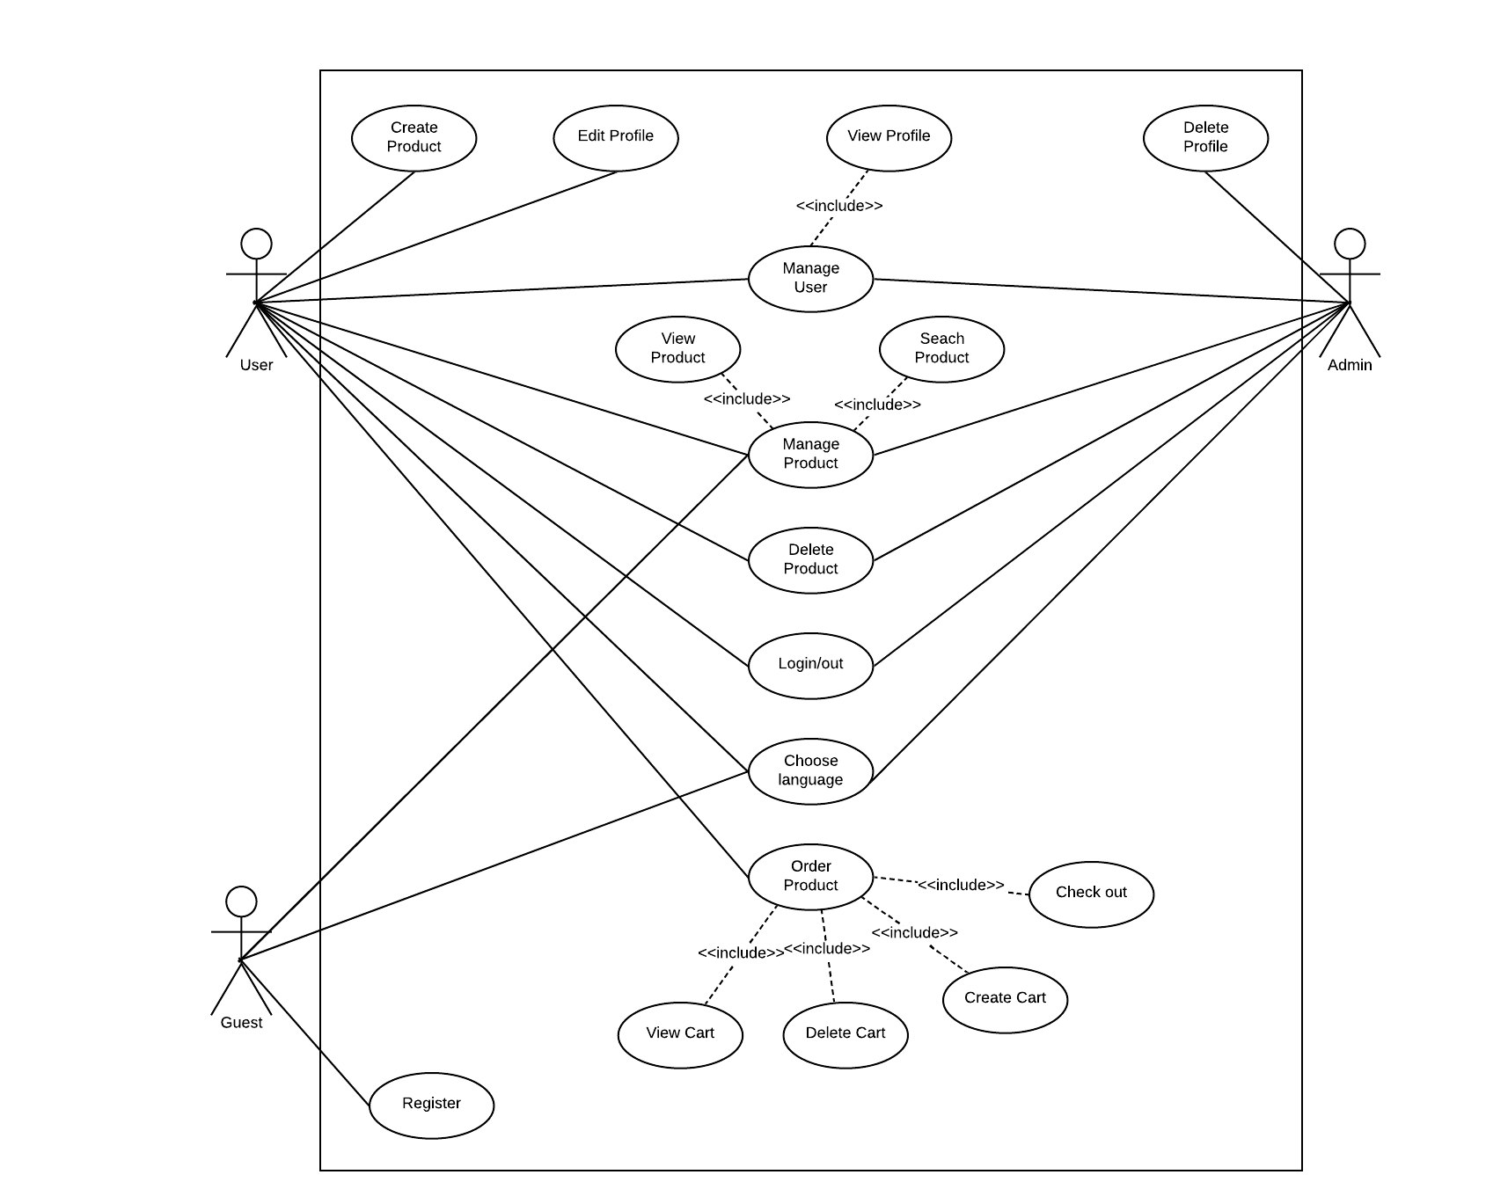

Use Case List:

|  |  |  |  |
| --- | --- | --- | --- |
| ID | Primary Actor | Features | Use Case name |
| UC-1 | User, Admin | Manage User | View Profile |
| UC-2 | User |  | Edit Profile |
| UC-3 | Admin |  | Delete Profile |
| UC-4 | User, Admin, Guest | Manage Product | View Product |
| UC-5 | User, Admin, Guest |  | Search Product |
| UC-6 | User |  | Create Product |
| UC-7 | User |  | Edit Product |
| UC-8 | User, Admin |  | Delete Product |
| UC-9 | User | Order Product | View Cart |
| UC-10 | User |  | Delete Cart |
| UC-11 | User |  | Create Cart |
| UC-12 | User |  | Check Out |
| UC-13 | User, Admin | Login/Logout |  |
| UC-14 | User, Admin, Guest | Choose language |  |
| UC-15 | Guest | Register |  |

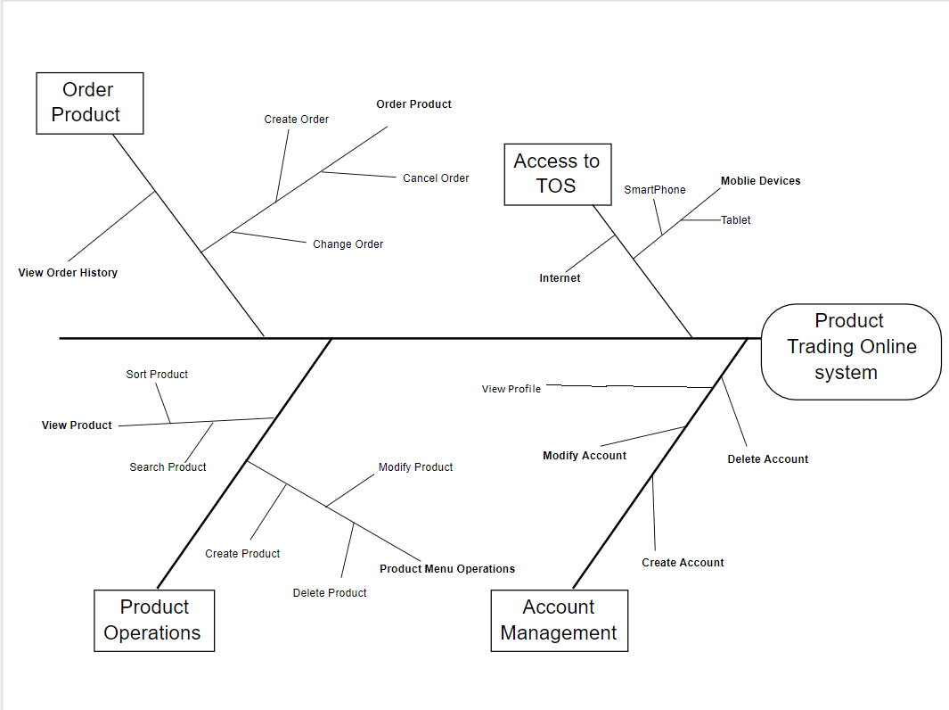System feature tree here:

Context diagram here:

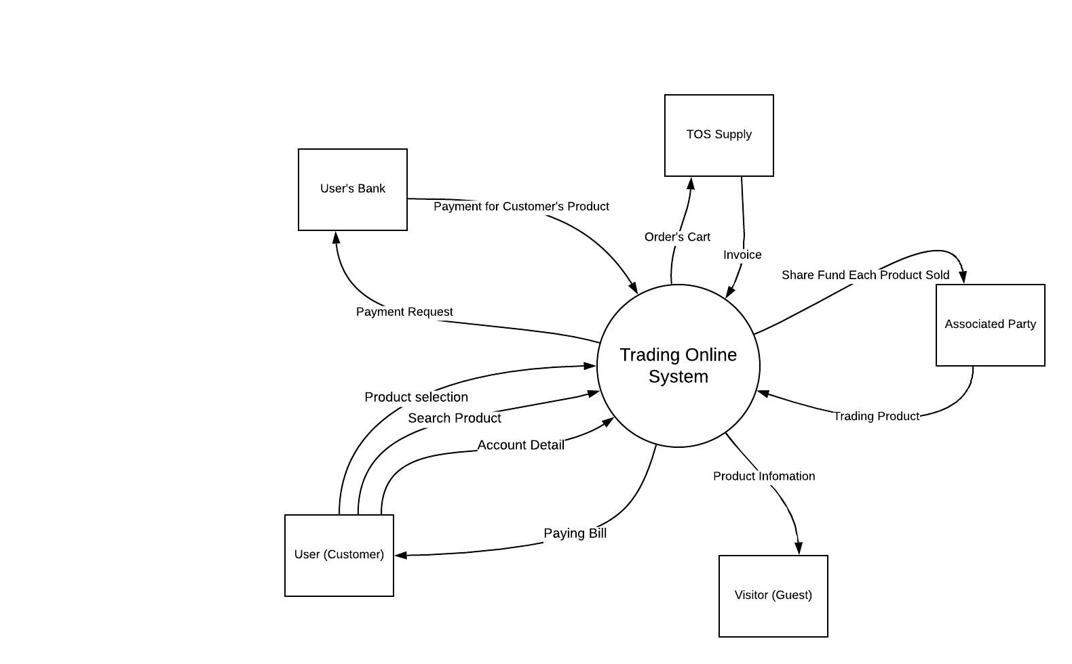

## System Feature Manage User

### Description

This feature will manage the user profile. Only uses for users and admin.

### Stimulus/Response Sequences

For admin can access these features: View Profile (of User), Delete Profile (of User).

For User can access these following features: View Profile, Edit Profile, Delete Profile.

### Functional View Profile.

GUI:

1. 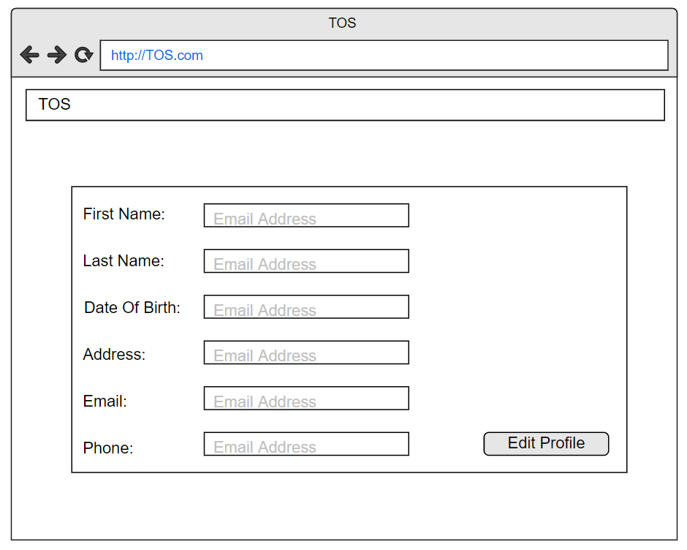For user (Web form)

Figure 3-1. Screen Design View Profile

1. For admin (Window Form)

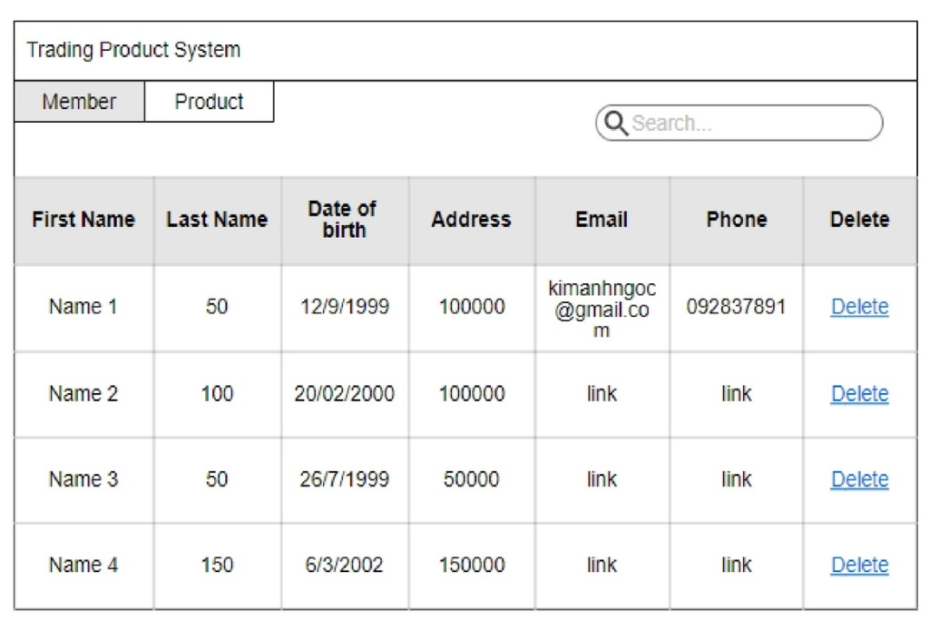

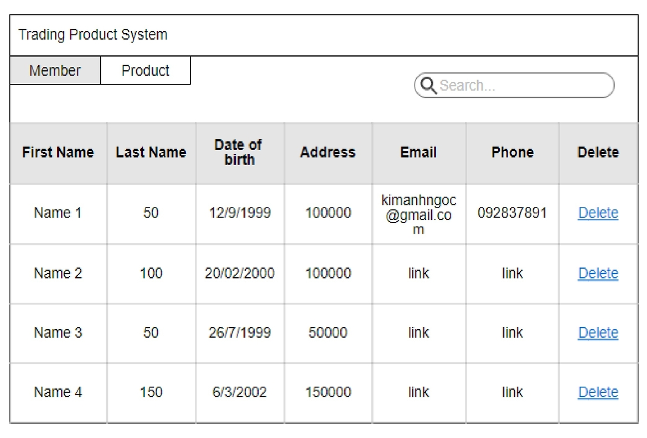

Figure 3-2. Screen Design View Profile (of Users)

|  |  |  |  |
| --- | --- | --- | --- |
| UC ID and Name: | View Profile | | |
| Created By: | HieuNV | Date Created: | 9/3/2020 |
| Primary Actor: | Admin, User | Second Actor: |  |
| Trigger: | N/A | | |
| Description: | The function allows trading product with write. | | |
| Preconditions: | **PRE-1.1** User has account on web  **PRE-1.2** User has logged on web | | |
| Postconditions: | **POST-1.1** When the normal flow completes successfully, a new account is created on the trading product System and user or admin must be login to system | | |
| Normal Flow: | **View Profile**   1. View profile 2. Guest and User click on avatar of owner 3. System will redirect the owner’s profile 4. Guest and User can see detail profile of owner | | |
| Alternative Flows: | N/A | | |
| Exceptions: | N/A | | |
| Priority: | Medium | | |
| Frequency of Use: | Medium | | |
| Business Rules: | **BR-1**: Account’s has to have all the information | | |
| Other Information: | N/A | | |
| Assumptions: | N/A | | |

### Function Edit Profire.

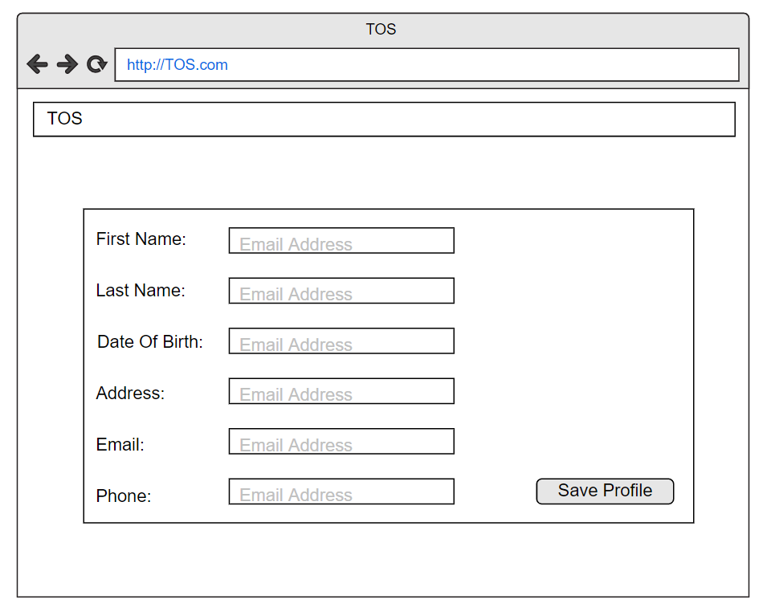GUI:

Figure 3-4. Screen Design for Edit Profile

|  |  |  |  |
| --- | --- | --- | --- |
| UC ID and Name: | Edit profile | | |
| Created By: | HieuNV | Date Created: | 9/3/2020 |
| Primary Actor: | User | Second Actor: |  |
| Trigger: | N/A | | |
| Description: | This function can help this user owner change profile of them when they want to change | | |
| Preconditions: | **PRE-1.1** User has account on web | | |
| Postconditions: | **POST-1.1** When the normal flow completes successfully, profile of them can update to database of the Product trading System and user must be view to profile | | |
| Normal Flow: | **Update profile**   1. User open Trading web. 2. System display Trading home page. 3. Guest clicks button edit profile menu on navigation bar. 4. System displays the update form in the dialog box. 5. Guest enters full name, job, date of birth, address, password, re password on the registration form.   7. Guest clicks Update button on the registration form.  8. System update account with field provided.  9. System generates an activation link for the account.  10. System displays a message to notify that account updated | | |
| Alternative Flows: | N/A | | |
| Exceptions: | N/A | | |
| Priority: | Medium | | |
| Frequency of Use: | Medium | | |
| Business Rules: | **BR-1**: Account’s information field should not be empty  **BR-2**: Account’s Email has to be existed | | |
| Other Information: | N/A | | |
| Assumptions: | N/A | | |

### Function Delete Profire.

GUI:

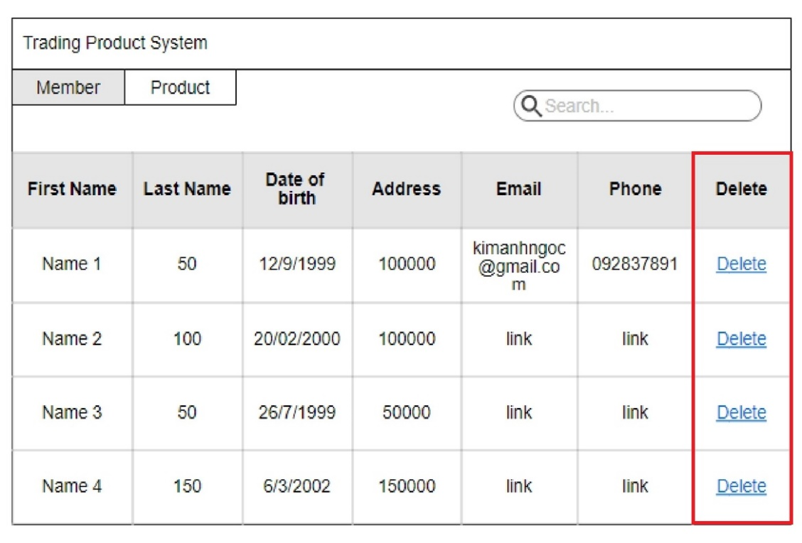

Figure 3-6. Screen Design of Delete Profile (for Admin)

|  |  |  |  |
| --- | --- | --- | --- |
| UC ID and Name: | Delete Profile | | |
| Created By: | HieuNV | Date Created: | 9/3/2020 |
| Primary Actor: | Admin | Second Actor: |  |
| Trigger: | N/A | | |
| Description: | The function allows user delete product | | |
| Preconditions: | **PRE-1.1** User has account on QS web  **PRE-1.2** User has logged on QS web | | |
| Postconditions: | **POST-1.1** When the normal flow completes successfully, account is delete on the trading product System and user or admin must be login to system. | | |
| Normal Flow: | **Delete Profile**   1. Admin login window form. 2. Admin can see all the list off user, 3. If the user violated the rule, Admin can delete the user. | | |
| Alternative Flows: | N/A | | |
| Exceptions: | N/A | | |
| Priority: | Slow | | |
| Frequency of Use: | Medium | | |
| Business Rules: | N/A | | |
| Other Information: | N/A | | |
| Assumptions: | N/A | | |

## System Feature Manage Product

### Description

This feature will manage the product. Range of actor: User, Admin and Guest.

### Stimulus/Response Sequences

For admin can access these features: View Product, Search Product.

For User can access these following features: View Product, Search Product, Create Product, Edit Product, Delete Product.

For Guest can access these following features: View Product, Search Product.

### Function View Product

GUI:

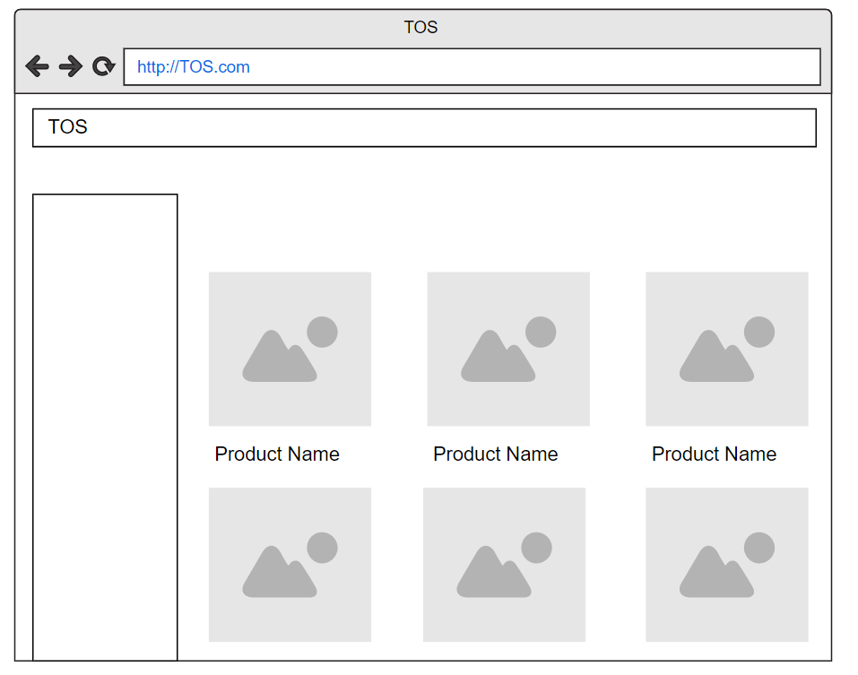

Figure 3-8. Screen Design of View Product

|  |  |  |  |
| --- | --- | --- | --- |
| UC ID and Name: | View Product | | |
| Created By: | HieuNV | Date Created: | 9/3/2020 |
| Primary Actor: | Admin, User, Guest | Primary Actor: | Admin, User, Guest |
| Trigger: |  | | |
| Description: | This function will let see the product (not a function) | | |
| Preconditions: | N/A | | |
| Postconditions: | **POST-1.1** When the normal flow completes successfully, they can view the product. | | |
| Normal Flow: | View Product   1. Open the web and they can view the product they want. | | |
| Alternative Flows: | N/A | | |
| Exceptions: | N/A | | |
| Priority: | Medium | | |
| Frequency of Use: | Medium | | |
| Business Rules: | N/A | | |
| Other Information: | N/A | | |
| Assumptions: | N/A | | |

### Function Search Product

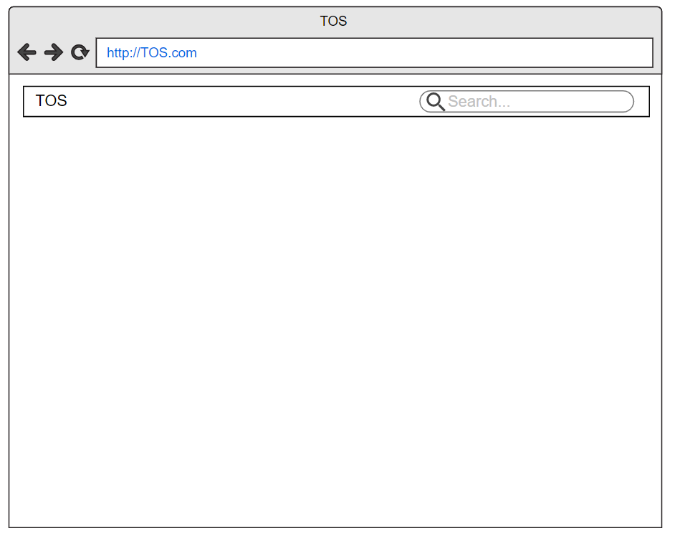GUI:

Figure 3-10. Screen Design of Search Product.

|  |  |  |  |
| --- | --- | --- | --- |
| UC ID and Name: | Search Product | | |
| Created By: | HieuNV | Date Created: | 9/3/2020 |
| Primary Actor: | Admin, User, Guest | Second Actor: |  |
| Trigger: | N/A | | |
| Description: | The function allows a everyone can search the product | | |
| Preconditions: | N/A | | |
| Postconditions: | N/A | | |
| Normal Flow: | **Search Product**   1. Guest enters search keyword on search box in navigation.   Guest clicks search button.   1. System displays the list of issuers matched with the search 2. keyword. Each Product is presented with title and content | | |
| Alternative Flows: | N/A | | |
| Exceptions: | N/A | | |
| Priority: | Low | | |
| Frequency of Use: | Medium | | |
| Business Rules: | N/A | | |
| Other Information: | N/A | | |
| Assumptions: | N/A | | |

### Function Create Product

GUI:

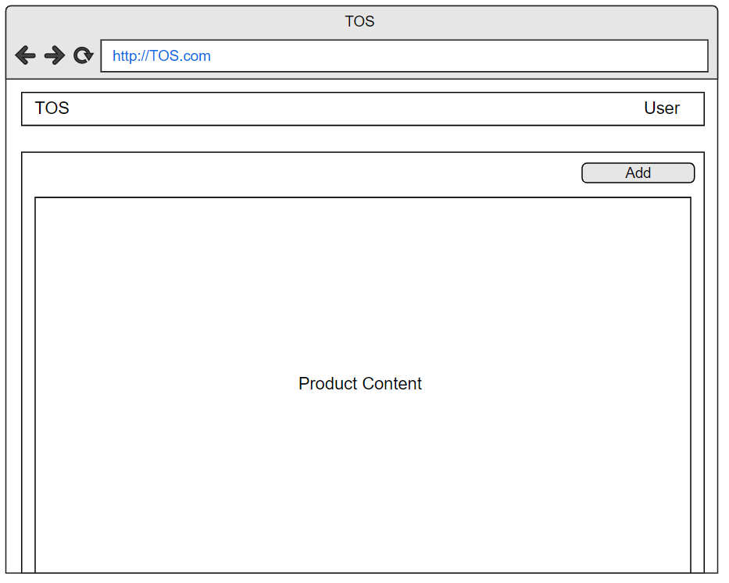

Figure 3-12. Screen Design of Create Product (1)

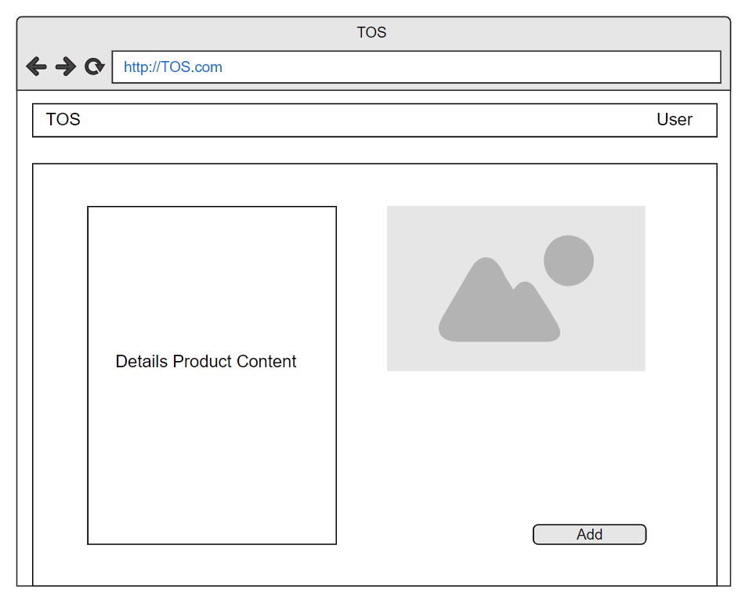

Figure 3-13. Screen Design of Create Product (2)

|  |  |  |  |
| --- | --- | --- | --- |
| UC ID and Name: | Create Product | | |
| Created By: | HieuNV | Date Created: | 9/3/2020 |
| Primary Actor: | User | Second Actor: |  |
| Trigger: | N/a | | |
| Description: | Allow user create product in inventory | | |
| Preconditions: | **PRE-1.1** User has account on web  **PRE-1.2** User has logged on web | | |
| Postconditions: | **POST-1.1**: When user finish create product, information of this product must be approved by a Manager.  **POST-1.2**: After being approved by management, the product must be updated and store in the database of the web | | |
| Normal Flow: | **Create Product**   1. User must access the inventory screen and choose add product function 2. User must fill all information of product need to create 3. Waiting approval by manager 4. When this product being approved by management, create successful. If this product is not approved create fail and user receive notification from manager | | |
| Alternative Flows: | If users leave out any information about the product blank system sent message: “Must fill all information of product” | | |
| Exceptions: | Image of product not valid type | | |
| Priority: | Medium | | |
| Frequency of Use: | Medium | | |
| Business Rules: | **BR-1:** Photos provided must be real pictures of the product | | |
| Other Information: | N/a | | |
| Assumptions: | N/a | | |

### Function Edit Product

GUI:

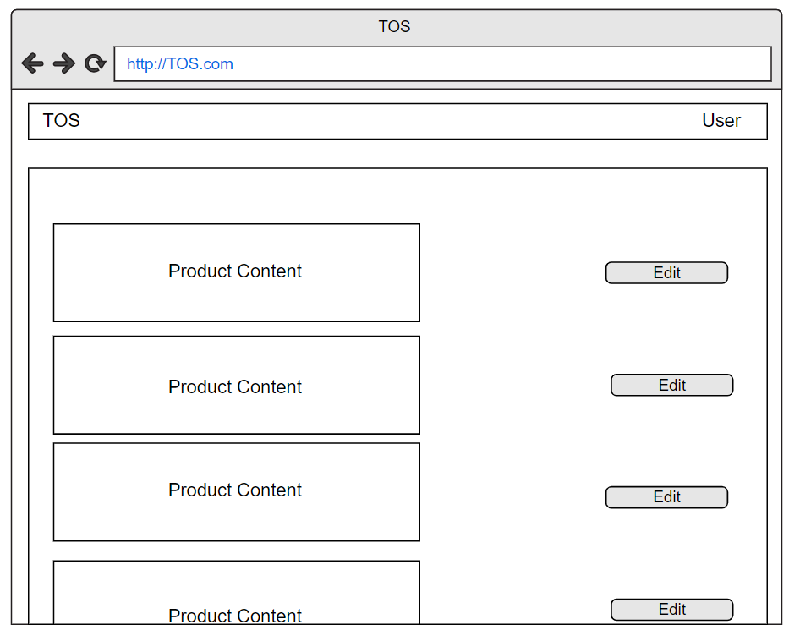

Figure 3-15. Screen Design of Edit Product (1)

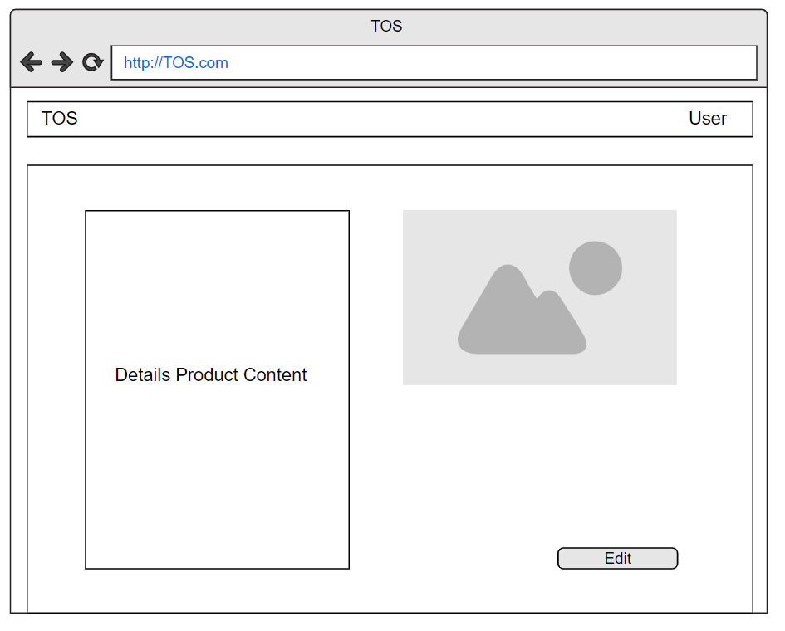

Figure 3-16. Screen Design of Edit Product (2)

|  |  |  |  |
| --- | --- | --- | --- |
| UC ID and Name: | Edit Product | | |
| Created By: | HieuNV | Date Created: | 9/3/2020 |
| Primary Actor: | User | Second Actor: |  |
| Trigger: | N/a | | |
| Description: | Allow user edit information of product | | |
| Preconditions: | **PRE-1.1** User has account on web  **PRE-1.2** User has logged on web | | |
| Postconditions: | After finish this function, the product must be updated and store in the database of TS | | |
| Normal Flow: | **Edit Product**   1. User must access the inventory screen, list of product is displayed and user must choose update product function. 2. User must fill all information of product need to edit 3. After save, edit successful. | | |
| Alternative Flows: | If users leave out any information about the product blank system sent message: “Must fill all information of product” | | |
| Exceptions: | N/a | | |
| Priority: | Medium | | |
| Frequency of Use: | Low | | |
| Business Rules: | N/a | | |
| Other Information: | N/a | | |
| Assumptions: | N/a | | |

### Function Delete Product

GUI:

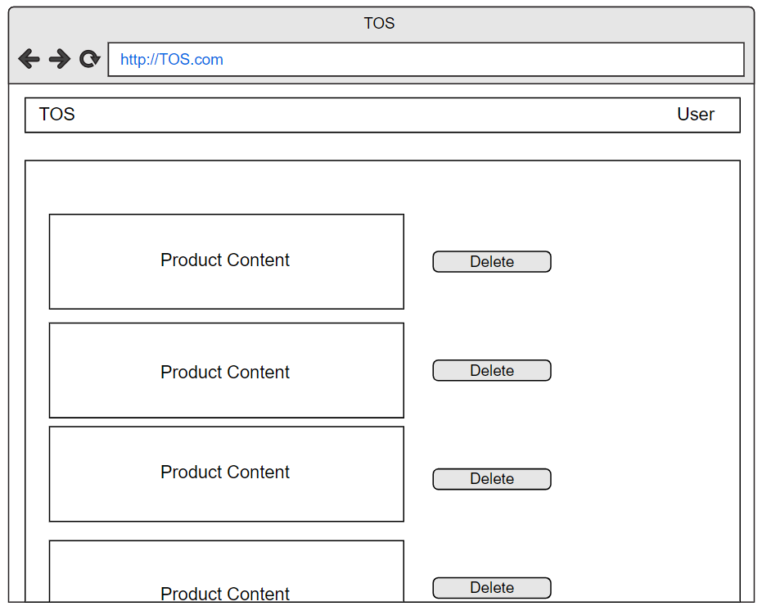

Figure 3-18. Screen Design of Delete Product.

|  |  |  |  |
| --- | --- | --- | --- |
| UC ID and Name: | Delete Product | | |
| Created By: | HieuNV | Date Created: | 9/3/2020 |
| Primary Actor: | User, Admin | Second Actor: |  |
| Trigger: | N/a | | |
| Description: | Allow delete product | | |
| Preconditions: | **PRE-1.1** User has account on TS web  **PRE-1.2** User or Admin has logged on TS web | | |
| Postconditions: | After finish this function, the product must be delete in the database of TS | | |
| Normal Flow: | **Delete Product**   1. User must access the inventory screen, list of product is displayed and user must choose delete product function. 2. System sent a massage to confirm delete product and delete successful | | |
| Alternative Flows: | N/a | | |
| Exceptions: | N/a | | |
| Priority: | Medium | | |
| Frequency of Use: | Low | | |
| Business Rules: | N/a | | |
| Other Information: | N/a | | |
| Assumptions: | N/a | | |

## System Feature Order Product

### Description.

This feature will manage the order product. Only uses for users.

### Stimulus/Response Sequences

For admin and guest can’t access these features.

For User can access these following features: View Order, Create Order, Delete Order and Checkout.

### Function View Cart

GUI:

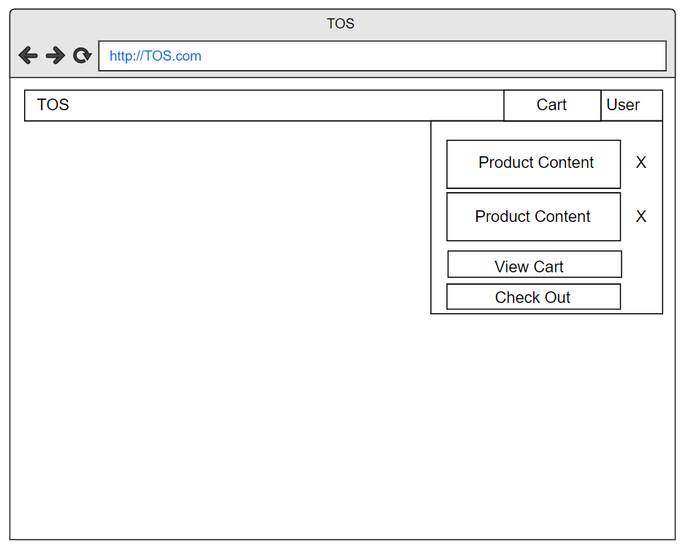

Figure 3-20. Screen Design for View Cart

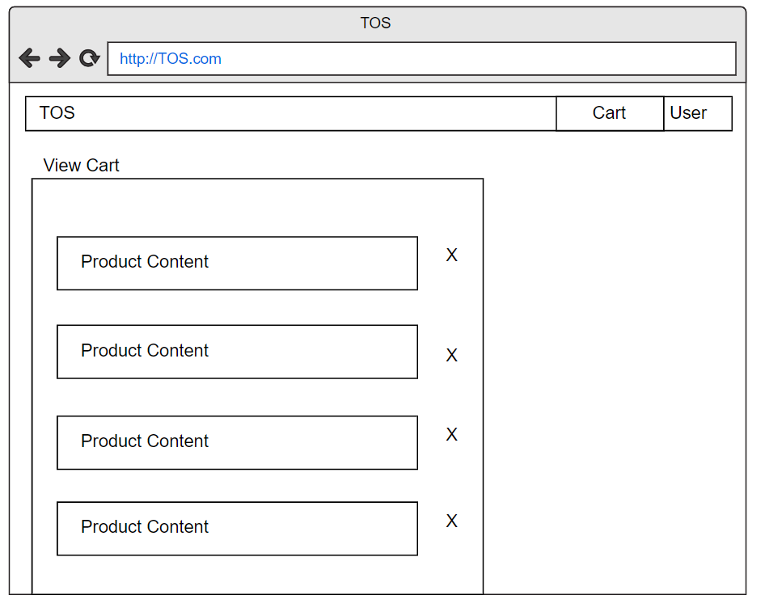

Figure 3-21. Screen Design for View Cart (2)

|  |  |  |  |
| --- | --- | --- | --- |
| UC ID and Name: | View Cart | | |
| Created By: | HieuNV | Date Created: | 9/3/2020 |
| Primary Actor: | User | Second Actor: |  |
| Trigger: | N/a | | |
| Description: | Allow user, guest view cart list of ordered | | |
| Preconditions: | N/a | | |
| Postconditions: | List of ordered must be displayed | | |
| Normal Flow: | 1. When user click at preview cart, message box displayed with shortlist of ordered 2. User access into view cart full list of product displayed with details of ordered | | |
| Alternative Flows: | N/a | | |
| Exceptions: | N/a | | |
| Priority: | Medium | | |
| Frequency of Use: | Medium | | |
| Business Rules: | N/a | | |
| Other Information: | N/a | | |
| Assumptions: | N/a | | |

### Function Create Cart

GUI:

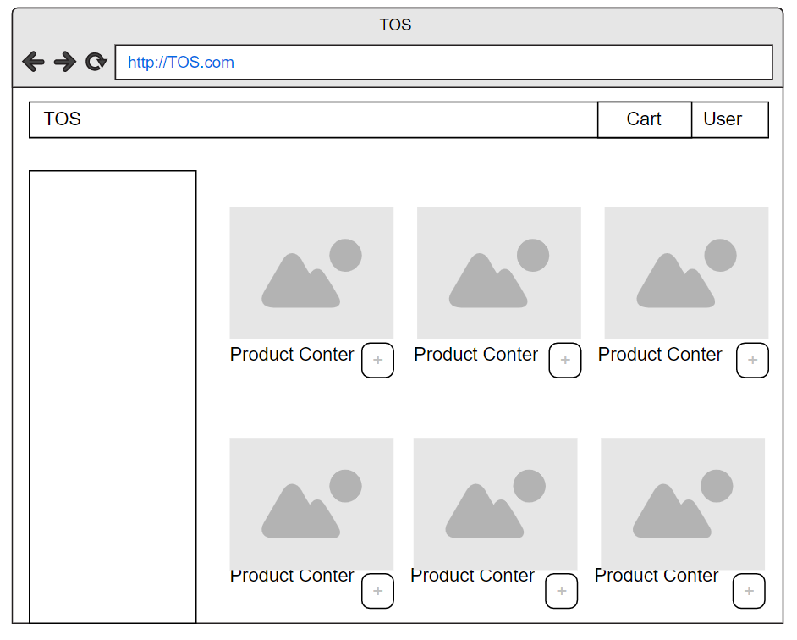

Figure 3-22. Screen Design for Create Cart

|  |  |  |  |
| --- | --- | --- | --- |
| UC ID and Name: | Create Cart | | |
| Created By: | HieuNV | Date Created: | 9/3/2020 |
| Primary Actor: | User | Second Actor: |  |
| Trigger: | N/a | | |
| Description: | Allow user, guest create cart | | |
| Preconditions: | N/a | | |
| Postconditions: | After finish this function, the cart must be store in list order of the database of the TS | | |
| Normal Flow: | At home screen, user click into cart icon at product want to order,   1. Cart will create successful | | |
| Alternative Flows: | N/a | | |
| Exceptions: | N/a | | |
| Priority: | Medium | | |
| Frequency of Use: | Medium | | |
| Business Rules: | N/a | | |
| Other Information: | N/a | | |
| Assumptions: | N/a | | |

### Function Delete Order

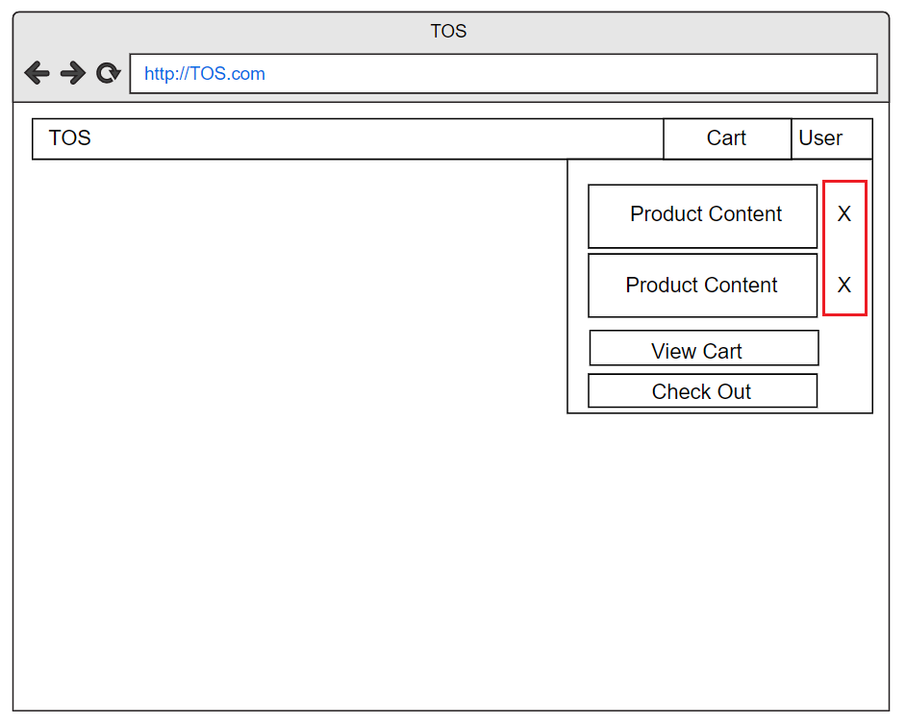GUI:

Figure 3-24. Screen Design for Delete Cart

|  |  |  |  |
| --- | --- | --- | --- |
| UC ID and Name: | UC-10: Delete Cart | | |
| Created By: | HieuNV | Date Created: | 9/3/2020 |
| Primary Actor: | User | Secondary Actors: |  |
| Trigger: | N/A | | |
| Description: | This function will let the user can delete the product that they don’t want in their cart. | | |
| Preconditions: | **PRE-1.1** User has account on web  **PRE-1.2** User has logged on web  **PRE-1.3** The User Cart has to be contain at least 1 or more product | | |
| Postconditions: | **POST-1.1** When the normal flow completes successfully, they can delete the product in the cart. | | |
| Normal Flow: | **Delete Cart**   1. User login into the system 2. In the website, the user has to choose the product they want to put in the cart 3. After done shopping, the user can go to their cart and delete the product that they don’t want. | | |
| Alternative Flows: | N/A | | |
| Exceptions: | N/A | | |
| Priority: | Medium | | |
| Frequency of Use: | Low | | |
| Business Rules: | **BR-1:** The cart must not be empty | | |
| Other Information: | N/A | | |
| Assumptions: | N/A | | |

### Function Checkout

GUI:

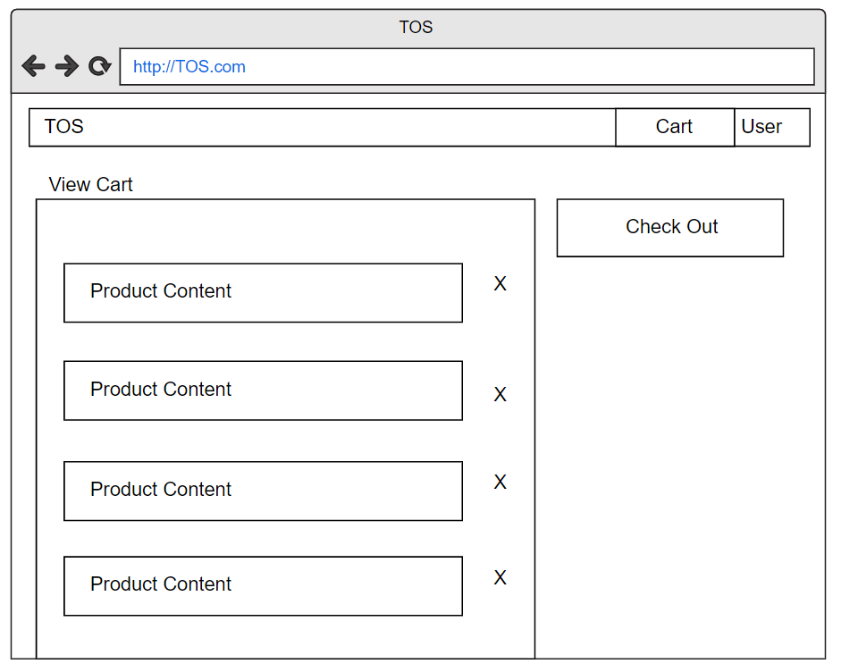

Figure 3-26. Screen Design for Checkout (1)

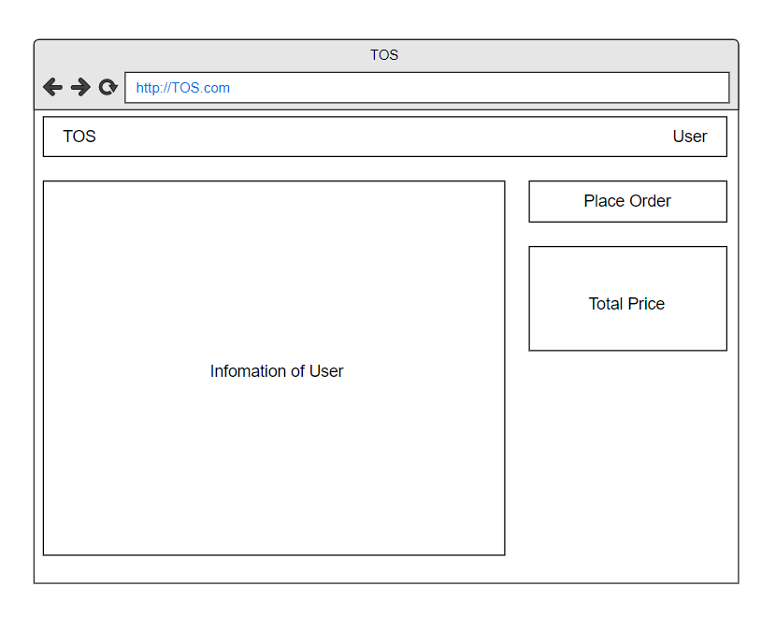

Figure 3-27. Screen Design for Checkout (2)

|  |  |  |  |
| --- | --- | --- | --- |
| UC ID and Name: | UC-12: Check out | | |
| Created By: | HieuNV | Date Created: | 9/3/2020 |
| Primary Actor: | User | Secondary Actors: |  |
| Trigger: | N/A | | |
| Description: | This function will let the user after ordering all the product they want in the shop, they checkout to get their product to being delivered on their place | | |
| Preconditions: | **PRE-1.1** User has account on web  **PRE-1.2** User has logged on web  **PRE-1.3** The User Cart has to be contain at least 1 or more product | | |
| Postconditions: | **POST-1.1** When the normal flow completes successfully, they can checkout and wait for their product to be delivered. | | |
| Normal Flow: | **Check-out**   1. User login into the system 2. In the website, the user has to choose the product they want to put in the cart 3. After done shopping, the user can go to their cart and do the check out. 4. In checkout, they can place order normally with their address | | |
| Alternative Flows: | If don’t fully provide their information, they have to fill all the information, so the deliver can know the place and your product can be delivered. | | |
| Exceptions: | N/A | | |
| Priority: | High | | |
| Frequency of Use: | High | | |
| Business Rules: | **BR-1**: They has to fill all the information about their address.  **BR-2**: The more information, the more easier for product to be delivered.  **BR-3**: The cart cannot be empty. | | |
| Other Information: | N/A | | |
| Assumptions: | N/A | | |

## System Feature Login/Logout

### Description

This feature will access more features from the store. Only uses for users and admin.

### Stimulus/Response Sequences

For Admin and User can access these features.

For Guest, the must use the register first before access to login/out.

### Function Login.

GUI:

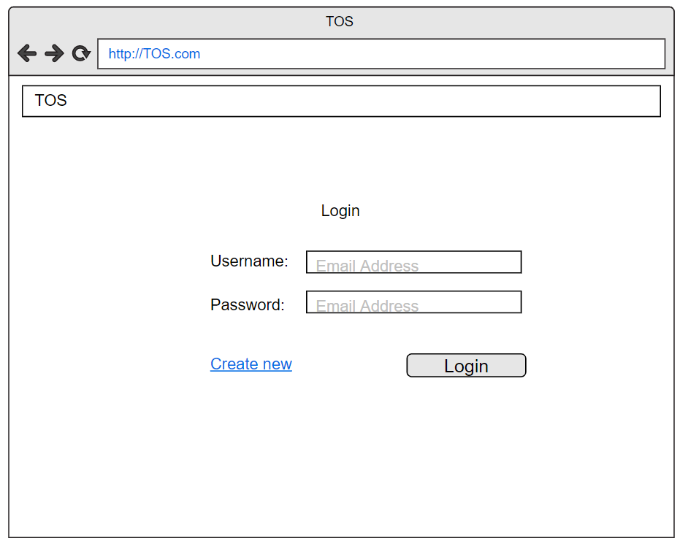

Figure 3-29. Screen Design for Login

|  |  |  |  |
| --- | --- | --- | --- |
| UC ID and Name: | UC-13: Login | | |
| Created By: | HieuNV | Date Created: | 9/3/2020 |
| Primary Actor: | Admin, User | Secondary Actors: |  |
| Trigger: | N/A | | |
| Description: | The function allows a user to be able to login in the software when he/she have registered an account and his/her account is still active. | | |
| Preconditions: | **PRE-1.1** User has account on web | | |
| Postconditions: | **POST-1.1** When the normal flow completes successfully, a new account is created on the System and user or admin must be login to system | | |
| Normal Flow: | **Login**   * + - 1. Display Login screen with the following fields: username, password, login and close button       2. User enter username & password into User Name & Password fields on the Login screen, then click on Login button.       3. Validate the entered username & password and then display Home screen | | |
| Alternative Flows: | N/A | | |
| Exceptions: | N/A | | |
| Priority: | High | | |
| Frequency of Use: | High | | |
| Business Rules: | **BR-1:** The 2 fields username, password hasn’t empty  **BR-2:** User must provide their account’s username address when resetting the account’s password | | |
| Other Information: | N/A | | |
| Assumptions: | N/A | | |

### Function Logout.

GUI:

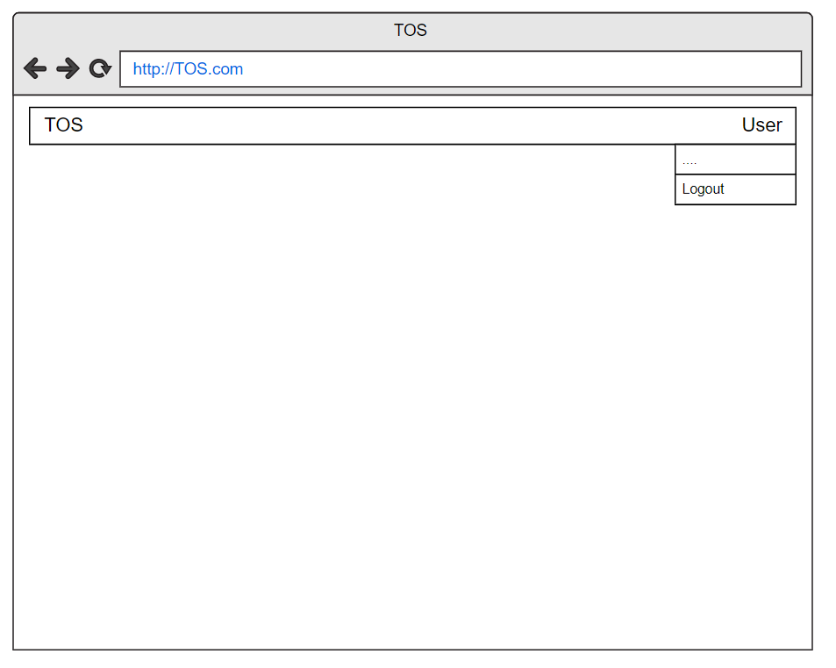

Figure 3-31. Screen Design for Logout

|  |  |  |  |
| --- | --- | --- | --- |
| UC ID and Name: | UC-13: Logout | | |
| Created By: | HieuNV | Date Created: | 9/3/2020 |
| Primary Actor: | Admin, User | Secondary Actors: |  |
| Trigger: |  | | |
| Description: | The function allows a user be able to logout in the software when he/she have logged an account and his/her account | | |
| Preconditions: | **PRE-1.1** User has account on web  **PRE-1.2** User has logged on web | | |
| Postconditions: | **POST-1.1** When the normal flow completes successfully | | |
| Normal Flow: | **Logout**   1. User login on system successful 2. User click to Button Logout 3. User will exit the system 4. QS will redirect user to Home Page | | |
| Alternative Flows: | N/A | | |
| Exceptions: | N/A | | |
| Priority: | Medium | | |
| Frequency of Use: | High | | |
| Business Rules: | N/A | | |
| Other Information: | N/A | | |
| Assumptions: | N/A | | |

## System Feature Choose language

### Description.

This feature will allow person who use the web can change the language.

### Stimulus/Response Sequences

Guest, User and Admin can access this feature.

### Function Choose Language

GUI:

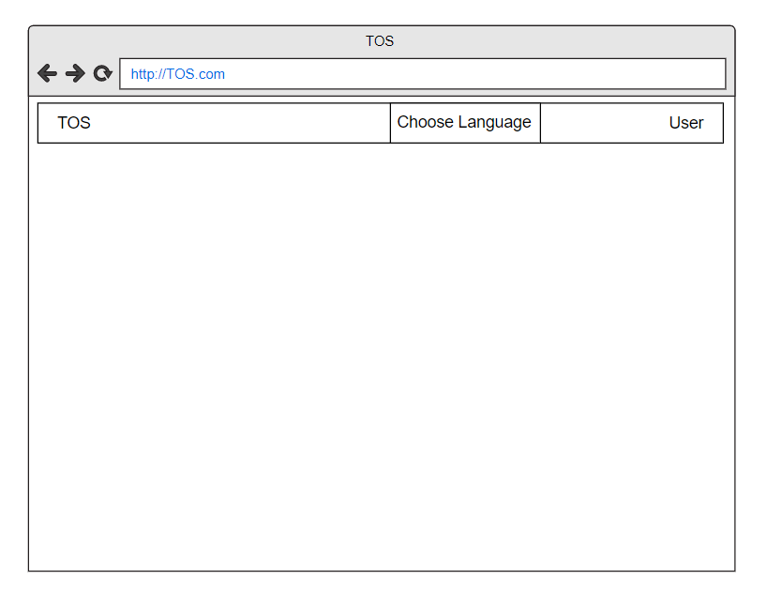

Figure 3-32. Screen Design for Choose Language

|  |  |  |  |
| --- | --- | --- | --- |
| UC ID and Name: | UC-14: Choose Language | | |
| Created By: | HieuNV | Date Created: | 9/3/2020 |
| Primary Actor: | Admin, Guest, User | Secondary Actors: |  |
| Trigger: | N/A | | |
| Description: | The function allows switch to other language | | |
| Preconditions: | N/A | | |
| Postconditions: | N/A | | |
| Normal Flow: | **Choose language**   1. User click to button Choose Language 2. Show list language system support for user choose 3. User click to Language want to switch 4. Immediately, all content will translate to that language | | |
| Alternative Flows: | N/A | | |
| Exceptions: | N/A | | |
| Priority: | Low | | |
| Frequency of Use: | Medium | | |
| Business Rules: | N/A | | |
| Other Information: | N/A | | |
| Assumptions: | N/A | | |

## System Feature Register

### Description

This feature will allow Guest can be Register to become a User and can access more feature like a User.

### Stimulus/Response Sequences

Only guest can access this feature.

### Function Register

GUI:

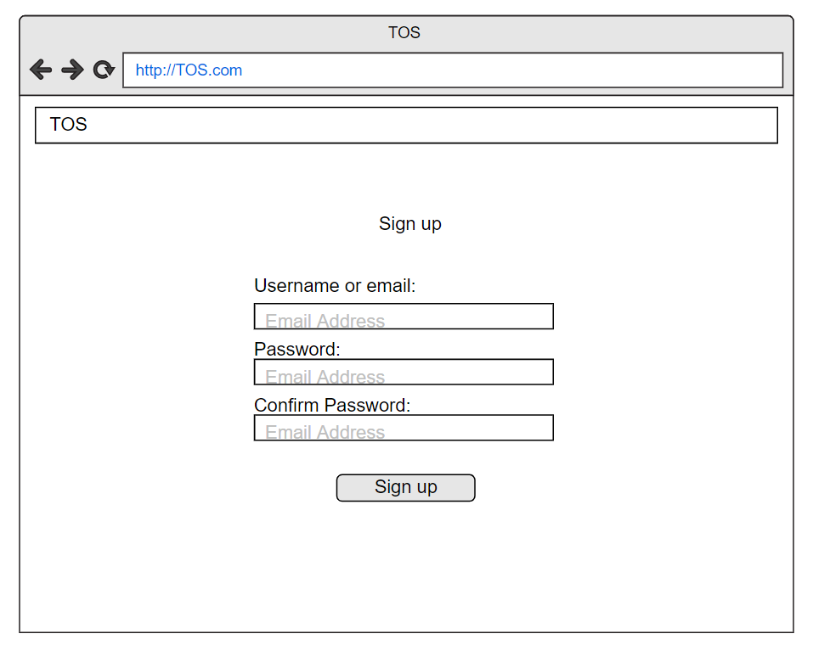

Figure 3-34. Screen Design for Register

|  |  |  |  |
| --- | --- | --- | --- |
| UC ID and Name: | UC-15: Register | | |
| Created By: | HieuNV | Date Created: | 9/3/2020 |
| Primary Actor: | Guest | Secondary Actors: |  |
| Trigger: | N/A | | |
| Description: | The function allows a user to be able to register in the software when he/she haven’t registered an account and his/her account is still active. | | |
| Preconditions: | **PRE-1.1** Guest has a valid email | | |
| Postconditions: | **POST-1.1** When the normal flow completes successfully, a new account is created | | |
| Normal Flow: | **Register**   1. Guest open desktop application. 2. System display home page. 3. Guest click Register menu on navigation bar. 4. System displays login/register dialog box. 5. System displays the registration form in the dialog box. 6. Guest enters username, full name, job, date of birth, address, password, re-password on the registration form. 7. Guest clicks Sign Up button on the registration form. 8. System creates a new account with field provided. 9. System generates an activation link for the account. 10. System sends an email with the activation link to provided email address. 11. System displays a message to notify that account has been created and activation email has been sent to the registered email address. 12. Guest visits his/her email account and open the activation email. 13. Guest clicks the activation link. 14. System activates the new account, then deletes the activations link from database. 15. System display a message to notify that the account has been activated. 16. System display the home page. | | |
| Alternative Flows: | N/A | | |
| Exceptions: | **E1 – Cannot communicate with API server.**  System displays error message.  **E2 – 24 hours since the activation email is sent, the Guest does not click the activation link.**  System will delete the account and the activation link from database. | | |
| Priority: | High | | |
| Frequency of Use: | High | | |
| Business Rules: | **BR-1:** Account’s email address must be valid.  **BR-2:** Account’s password must be at least 8 characters in length and must contain at least 1 uppercase letter, 1 lower case letter and 1 digit.  **BR-3:** Account’s password must not be stored as plain text. Instead it must be hashed using secure hash algorithm.  **BR-4:** When registering or changing password, user must enter new password twice  **BR-5:** A guest cannot register with an email that has already been registered.  **BR-6:** After registering, guest must activate their account with the activation link sent to the account’s email address. | | |
| Other Information: | N/A | | |
| Assumptions: | N/A | | |

# Data Requirements

## Logical Data Mode

Figure 4-1. Logical Data Model

## Data Dictionary

|  |  |  |  |  |
| --- | --- | --- | --- | --- |
| Data Element | Description | Composition or Data Type | Length | Values |
| User | Storing key information of users | + User ID  +User Name  + Email  + Phone  + Address |  |  |
| User ID | Primary key of user table, define user | int | max | Number integer of user ID set identify on |
| User Name | This is name of user | string | 50 | hyphens and commas permitted |
| Email | This is contact of user. Use when can’t contact with phone | string | 50 | local time; h = 0-23 inclusive; mm = 00, 15, 30, or 45 |
| Phone | This is phone off user | string | 9,10 |  |
| Address | This Address of user | string | 100 |  |
| Account | Storing account information when users log into the system | + Account ID  + Account Name  + Password  + Rule |  |  |
| Account ID | This is primary key of table account | int | max |  |
| Account Name | This is account name. user only can login if account name the same in data base | date, MM/DD/YYYY | 15 | default = current date if the current time is before the order cutoff time, else the next day; cannot be prior to current date |
| Rule | This distinguish user login to system is admin or user | + 1 is admin  + 2 is User  + 3 is Guess | 1 |  |
| Order | Store order and ship information | + Order ID  + User ID  + Order Date  + Required Date  + Shipper Date  + Ship via  + Ship Name  + Ship Address  + Ship City  + Ship Region  + Ship Postal Code  + Ship Country |  |  |
| Order ID | This is primary key of order table | integer | max | initial value is 1 |
| User ID | This user to foreign key with user table | integer | max | incomplete, accepted, prepared, pending delivery, delivered, canceled |
| Order Date | This is date when user order product | date, MM/DD/YYYY |  |  |
| Required Date | This is date when company accepted this order and notify shipper date for user | date, MM/DD/YYYY |  |  |
| Shipper Date | The date actually shipper | date, MM/DD/YYYY |  |  |
| Ship Via | This is id of company ship for order | food item description  + food item price |  |  |
| Shipper Name | This is the name of shipper company | String | 50 |  |
| Ship Address | This is the address of company | date, MM/DD/YYYY |  |  |
| Ship City | This is city of company shipper | String | 50 |  |
| Ship Postal Code | Code of company shipper | string | 50 |  |
| Ship Country | This is shipper company country | string | 50 |  |
| Product | Storing Product information when users log into the system | + Product ID  + ProductName  + Supplier ID  + Category ID  + Quantity  + Unit Price  + Units in Stock  + Units on Order  + Discount |  |  |
| ProductName | Show the name of a product | string | 150 |  |
| Product ID | ID can make a different between products | integer | Max | + ID with an initial value of 1 |
| Suppliers ID | ID is to show where the product is come from | integer | max | + ID with an initial value of 1 |
| Category ID | ID is separate each product with different uses | integer | max | + ID with an initial value of 1 |
| Quantity | Show how much the user want to have in a product | integer | max |  |
| Unit Price | Show the price of product | AAA-EEE-NNNN XXXX for area code (A), exchange (E), number (N), and extension (X) | max |  |
| Units in Stock | Show whenever the product is remain on the shop | integer | max |  |
| Units on Order | Show how many product units in one order | integer | max |  |
| Discount | Discount for the product | integer | 100 |  |

## Reports

|  |  |
| --- | --- |
| **Report ID** | **Fl-RPT-1** |
| Report Title | Orders history of a user |
| Report Purpose | The sponsor wants to see a list of all the product that the user has purchase before within a defined period of up to 6 months before the current date, so he can rearrange the specific way he likes. |
| Priority | Medium |
| Report User | User |
| Data Sources | Database of product set in the website |
| Frequency and Disposition | Reports are generated at the request of a User. Data in the report is static. The report is displayed on the user's web browser screen on a computer, tablet or smartphone. It can be printed if the display device allows printing. |
| Visual Layout | Landscape mode |
| Report Body | Display fields and column headers:  ■ Ordinal number  ■ Order date  ■ Product displayed on screen  ■ Number of Orders  ■ Number of Product in Orders  ■ Number of Successful Orders |
| End-of-Report Indicator | None. |
| Interactivity | Sponsors can drill down to see the composition and information of each image in the order of the list that the site shows to users. |
| Security Access Restrictions | Only special users can see the posting history as well as upload or download data |

## Data Acquisition, Integrity, Retention, and Disposal

DI-1: TOS will list people who interact with the web regularly such ordering, viewing, purchasing, etc. Now that the user is saved to the web's data so that the web can take action, suitable. New each user more, improve user performance.

DI-2: TOS will store a list of Ordered Product by users.

# External Interface Requirements

## User Interfaces

UI-1: The Product Trading Online System screen displays shall conform to the Process Impact Internet

UI-2: The system shall provide a help link from each displayed webpage to explain how to use that  
page.

UI-3: The webpages shall permit complete navigation and product item selection by using the keyboard alone, in addition to using mouse and keyboard combinations.

## Software Interfaces

SI-1: Product Trading Online System

SI-1.1: The customer (User) shall transmit the quantities of product items ordered to the Product Trading Online through a programmatic interface.

SI-1.2: The customer (User) shall poll the Product Trading Online to determine whether a requested product item is available.

SI-1.3: When the Product Trading Online notifies the customer that a specific item is no longer  
available, the customer (User) shall remove that item from the cart.

## Hardware Interfaces

● All available web browsers: Chrome, Firefox, ...

● Internet, 3G, 4G, 5G, ...

● Devices can be connected to websites

## Communications Interfaces

CI-1: The TOS shall send an email or text message (based on user account settings) to the User to  
confirm acceptance of an order, price, and delivery instructions.

CI-2: The TOS shall send an email or text message (based on user account settings) to the User to  
report any problems with a meal order or delivery

CI-3: Communication between different parts of the web is important because they depend on each other. However, the manner in which the communication is reached does not matter to the web and is therefore handled by the underlying operating systems for the web portal.

# Quality Attributes

## Usability

USE-1: The TOS shall allow a User to retrieve the previous products ordered with a single interaction.

USE-2: 95% of new users shall be able to successfully order a Product without errors on their first try.

USE-3: The Product’s information will be 100% accurate for Customer to order.

## Performance

PER-1: Any response must be within 2 seconds or less

PER-2: After performing any function, there are always respond within 1 seconds (loading process, save success,...)

PER-3: The system shall display confirmation messages to users within an average of 3 seconds and a maximum of 6 seconds after the user submits information to the system.

## Security

SEC-1: When signup, guest need to create account with real name, username must have more than 6 characters, password must have more than 8 character included: letter, number. Guest need to agree with web site ‘s privacy

SEC-2: Users shall be required to log on to the COS for all operations except viewing a Product.

SEC-3: No user’s information, properties loss, insult from thirds party for bad behaviors.

SEC-4: The system shall permit User to view only orders that they placed.

## Safety

SAFE-1: If there is extensive damage to a wide portion of the database due to catastrophic failure, such as a disk crash, the recovery method restores a past copy of the database that was backed up to archival storage (typically tape) and reconstructs a more current state by reapplying or redoing the operations of committed transactions from the backed up log, up to the time of failure.

## Availability

AVB-1: The TOS shall be available at least 98% of the product to provide to the customer, the delivery with be 100% arrived in time with no breaking or changing the product on the go.

# Internationalization and Localization Requirements

Because Vietnam is the most users from Viet Nam, so app version toward Vietnamese is prioritized. Furthermore, the TOS web will provide more English and more in the future.

# Other Requirements

There are many different types of users: user, Administrator, guest, etc. Depending on the type of user, access rights are determined. That means that if the user is an administrator, he can modify the data, delete, append, etc.

Appendix A: Glossary

The following are the list of conventions and acronyms used in this document and the project as well:

* Admin: A login id representing a user with user administration privileges to the software
* User: A general login id assigned to most users
* Client: Intended users for the software
* SQL: Structured Query Language; used to retrieve information from a database
* SQL Server: A server used to store data in an organized format ¬ Layer: Represents a section of the project
* User Interface Layer: The section of the assignment referring to what the user interacts with directly
* Application Logic Layer: The section of the assignment referring to the Web Server. This is where all computations are completed
* Data Storage Layer: The section of the assignment referring to where all data is recorded
* Use Case: A broad level diagram of the project showing a basic overview
* Class diagram: It is a type of static structure diagram that describes the structure of a system by showing the system’s cases, their attributes, and the relationships between the classes
* Interface: Something used to communicate across different mediums

Unique Key: Used to differentiate entries in a database

Appendix B: Analysis Models

<This optional section includes or points to pertinent analysis models such as data flow diagrams, feature trees, state-transition diagrams, or entity-relationship diagrams. You might prefer to insert certain models into the relevant sections of the specification instead of collecting them at the end.>